Composite Pattern
# Source: AI Source: Provided by: [Data Path: Persons Table -> ID Column: 1, Name_En Column: Motasem Essam] -> From: [ChatGPT] on [1/23/2026]
The Composite Pattern allows you to treat individual objects and compositions of objects uniformly.
👉 Think of it like a folder system: a folder can contain files or other folders, and you can perform the same operations on both.

🔑 Key Points
# Source: AI Source: Provided by: [Data Path: Persons Table -> ID Column: 1, Name_En Column: Motasem Essam] -> From: [ChatGPT] on [1/23/2026]
• Combines objects into tree structures
• Lets clients treat single objects and groups the same way
• Useful for hierarchical structures like trees, menus, or graphics

❌ Bad Example
# Source: AI Source: Provided by: [Data Path: Persons Table -> ID Column: 1, Name_En Column: Motasem Essam] -> From: [ChatGPT] on [1/23/2026]
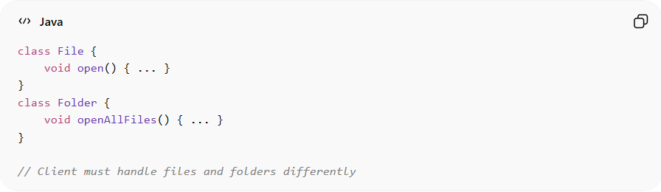
class File {
void open() { ... }
}
class Folder {
void openAllFiles() { ... }
}

// Client must handle files and folders differently
Problems:
• Client must know if it’s a file or folder
• Violates Open/Closed Principle
• Difficult to scale for nested structures

✅ Good Example
# Source: AI Source: Provided by: [Data Path: Persons Table -> ID Column: 1, Name_En Column: Motasem Essam] -> From: [ChatGPT] on [1/23/2026]
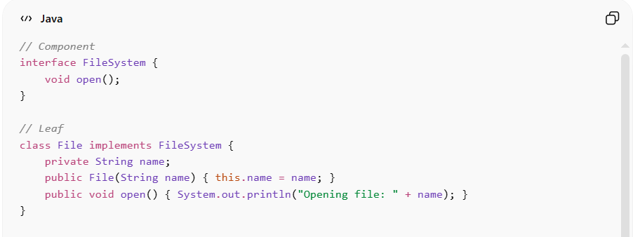
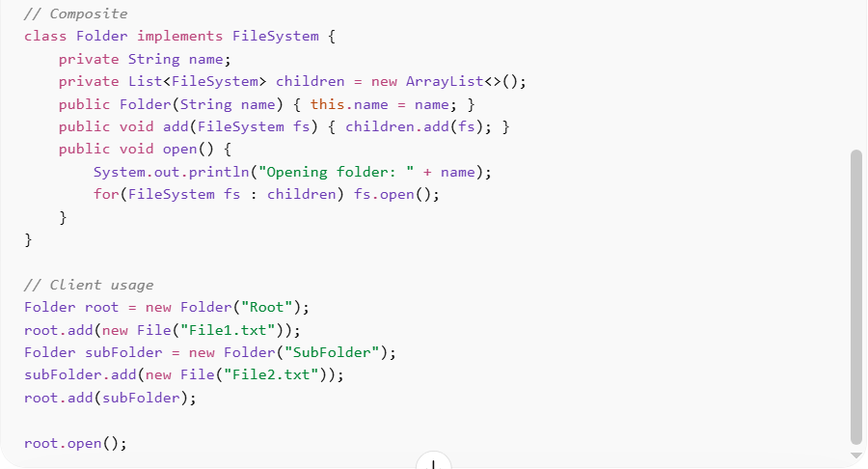
// Component
interface FileSystem {
void open();
}

// Leaf
class File implements FileSystem {
private String name;
public File(String name) { this.name = name; }
public void open() { System.out.println("Opening file: " + name); }
}

// Composite
class Folder implements FileSystem {
private String name;
private List<FileSystem> children = new ArrayList<>();
public Folder(String name) { this.name = name; }
public void add(FileSystem fs) { children.add(fs); }
public void open() {
System.out.println("Opening folder: " + name);
for(FileSystem fs : children) fs.open();
}
}

// Client usage
Folder root = new Folder("Root");
root.add(new File("File1.txt"));
Folder subFolder = new Folder("SubFolder");
subFolder.add(new File("File2.txt"));
root.add(subFolder);

root.open();
Benefits:
• Client can treat individual and composite objects uniformly
• Simplifies tree-like structure handling
• Easy to add new leaf or composite objects
• Promotes scalability and maintainability

⚡ Advantages
# Source: AI Source: Provided by: [Data Path: Persons Table -> ID Column: 1, Name_En Column: Motasem Essam] -> From: [ChatGPT] on [1/23/2026]
• Simplifies complex hierarchical structures
• Reduces client-side conditional logic
• Supports recursive composition
• Encourages flexible, extendable designs

⚠️ Disadvantages
# Source: AI Source: Provided by: [Data Path: Persons Table -> ID Column: 1, Name_En Column: Motasem Essam] -> From: [ChatGPT] on [1/23/2026]
• Can make design more complex for simple hierarchies
• Overuse may complicate debugging
• Recursive operations can be resource-intensive for large trees

🛠️ Use Cases
# Source: AI Source: Provided by: [Data Path: Persons Table -> ID Column: 1, Name_En Column: Motasem Essam] -> From: [ChatGPT] on [1/23/2026]
• File systems – folders and files
• GUI components – windows, panels, buttons, labels
• Organizational hierarchies – managers, teams, employees
• Graphics editors – shapes, groups of shapes

